IIT – ian’s P A C E
216 - 217 ,2nd floor , Shopper’s point , S. V. Road. Andheri (West) Mumbai – 400058 . Tel: 26245223 / 09
Practice Question LEVEL-1 Permutation & Combinations

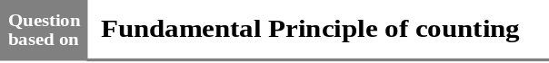

Q.1 The number of ways in which n distinct objects can be put into two different boxes is-
(A) n2 (B) 2n
(C) 2n (D) None of these

Q.2 The number of ways in which 3 persons can occupy 6 rooms separately is-
(A) 2 (B) 20
(C) 120 (D) 216

Q.3 Find the total number of ways of answering
5 objective type questions, each question having
4 choices.
(A) 46 (B) 54
(C) 63 (D) 45

Q.4 The number of ways in which first, second and third prize can be distributed among 5 competitors is (no person can get more than a prize)-
(A) 10 (B) 15
(C) 60 (D) 125

Q.5 A lock consists of three rings each marked with 10 different digits. The number of unsuccessful attempts to open the lock is-
(A) 310– 1 (B) 93
(C) 10P3–1 (D) 103–1

Q.6 5 Questions are asked in a question paper. Out of which two questions can be solved by two- two methods, two question by three-three and one question can be solved by only one method then the number of possible attempts to solve the question paper are-
(A) 25 (B) 22 . 32.1
(C) 144 (D) 288

Q.7 In how many ways 4 paintings can be hung on 4 walls of a room so that (i) one painting is hung on each wall and (ii) any number of paintings can be hung on any wall?
(A) 4, 4! (B) 12, 34
(C) 4!, 44 (D) 4!, 43

Q.8 In an examination, there are 3 multi-choice questions with one answer correct and each question has 4 alternatives. If a student is declared pass only when he attempts all questions correctly, then number of ways in which he can fail (if He attempts all the questions) is
(A) 1 (B) 12
(C) 27 (D) 63

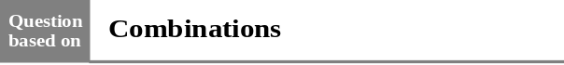

Q.9 nCr + nCr–1 equals-
(A) nCr+1 (B) n+1Cr
(C) n+1Cr–1 (D) n+1Cr+1

Q.10 If 28C2r : 24C2 r–4 = 225:11 then the value of r is-
(A) 14 (B) 8 (C) 5 (D) 7

Q.11 If nCn–4= 5 then the value of n is -
(A) 5 (B) 3 (C) 4 (D) 6

Q.12 There are 13 players of cricket out of which 4 are bowlers. In how many ways a team of eleven be selected from them so as to include at least two bowlers-
(A) 55 (B) 72
(C) 78 (D) None of these

Q.13 How many cricket eleven can be formed from
15 persons if captain is included in every team?
(A) 364 (B) 1365
(C) 1001 (D) 1000
Q.14 In how many ways a team of 11 be chosen from 20 students of a class so that 2 particular students are always included and 5 are always excluded?
(A) 715 (B) 70
(C) 1365 (D) None of these

Q.15 In how many ways can a committee of 6 be formed out of 6 men and 4 women so that committees include at the most 2 women?
(A) 90 (B) 185 (C) 115 (D) 210

Q.16 The number of committees formed by taking
5 men and 5 women from 6 women and 7 men are -
(A) 252 (B) 125 (C) 126 (D) 64

Q.17 Out of 6 boys and 4 girls a group of 7 is to be formed. How many such groups are possible if boys are to be in majority?
(A) 120 (B) 90 (C) 100 (D) 80

Q.18 The total number of ways to purchase one or more books from 4 books by a student are-
(A) 15 (B) 16
(C) 14 (D) None of these

Q.19 In a hall there are 10 bulbs and their 10 buttons. In how many ways this hall can be enlightened?
(A) 102 (B) 1023 (C) 210 (D) 10!

Q.20 The number of ways in which n distinct things can be put into two different boxes so that no box remains empty, is-
(A) n2 – 1 (B) n2 – 2
(C) 2n – 1 (D) 2n – 2

Q.21 A candidate is required to answer 6 questions out of 10 which are divided into two groups each consisting of 5 questions. In how many ways can he attempt 6 questions if he is not allowed to answer more than 4 questions from each section?
(A) 100 (B) 200
(C) 300 (D) 400

Q.22 If 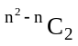= 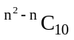, then n equals-
(A) 12 (B) 4 only
(C) –3 only (D) 4 or – 3
Q.23 A bag contains 9 balls marked with digits
1, 2, ...., 9. If two balls are drawn from the bag, then number of ways of getting the sum of the digits on balls as odd number is-
(A) 20 (B) 29 (C) 9C2 (D) 9P2

Q.24 In an election 3 persons are to be elected from
6 candidates. A voter can cast any number of votes but not more than the candidates to be elected. In how many ways can he cast his vote?
(A) 41 (B) 20 (C) 15 (D) 6

Q.25 In an election the number of candidates is one more than the number of members to be elected. A voter can cast any number of votes but not more than the candidates to be elected. If a voter can cast his vote in 30 ways, then the number of the candidates is-
(A) 4 (B) 5
(C) 6 (D) None of these

Q.26 The number of groups formed from 3 books of physics, 4 books of mathematics and 5 books of chemistry when each group contains at least one book of each subject-
(A) 3255 (B) 1670 (C) 4820 (D) 1560

Q.27 A father with 7 children takes 4 of them at a time to the zoo, as often as he can without taking the same four children together more than once. How often will he go? How often will each child go?
(A) 30, 10 (B) 35, 15
(C) 30, 20 (D) 35, 20

Q.28 Two groups of players consist of 6 and 8 players. In how many ways can a team of 11 players be selected from these two groups if at least
4 players are to be included from the first group?
(A) 334 (B) 344 (C) 120 (D) 168

Q.29 A man has 7 relatives, of which 4 are ladies and
3 gents, his wife has also 7 relatives, of which
3 ladies and 4 gents. In how many ways can they invite 3 ladies and 3 gents when there are
3 relatives of man and 3 relatives of his wife-
(A) 324 (B) 485
(C) 458 (D) None of these
Q.30 Given five different green dyes four different blue dyes and three different red dyes how many combinations of dyes can be chosen taking at least one green and one blue dyes-
(A) 1345 (B) 3720
(C) 4675 (D) 7943

Q.31 If α = mC2, then αC2 is equal to -
(A) m+1 C4 (B) m–1C4
(C) 3.m+2C4 (D) 3.m+1C4

Q.32 A committee of 5 is to be formed out of 6 gents and 4 ladies. In how many ways this can be done when atmost two ladies are included?
(A) 186 (B) 286
(C) 386 (D) None of these

Q.33 Everybody in a room shakes hands with every body else. If total number of hand-shaken is
66 then total number of persons in the room is-
(A) 11 (B) 12 (C) 13 (D) 14

Q.34 In a class tournament every student has to play a game with one another. If 2 students fell ill after playing 3 games each, (they never play with each other) and in total 84 games were played, then the number of students in the class is -
(A) 15 (B) 10
(C) 20 (D) None of these

Q.35 In a football championship, 153 matches were played. Every team played one match with each other. The number of teams participating in the championship is-
(A) 17 (B) 18
(C) 9 (D) None of these

Q.36 In how many ways can a game of tennis be played from 3 men and 4 women when each team contains one man and one woman-
(A) 72 (B) 36
(C) 42 (D) 144

Q.37 In how many ways can a mixed double tennis game be arranged from 7 married couples, if no husband and wife play in the same game?
(A) 28 (B) 70
(C) 210 (D) 420
Q.38 On the occasion of Dipawali festival each student of a class sends greeting cards to the others. If there are 20 students in the class, then the total number of greeting cards exchanged by the students is-
(A) 20C2 (B) 2.20C2
(C) 2. 20P2 (D) None of these

Q.39 A bag contains 6 different white and 5 different black balls. 4 balls are drawn at a time. The number of ways in which all the four will be of the same colour is-
(A) 25 (B) 20
(C) 16 (D) none of these

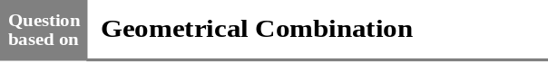

Q.40 In a plane there are 10 points out of which 4 are collinear, then the number of triangles that can be formed by joining these points are-
(A) 60 (B) 116
(C) 120 (D) None of these

Q.41 The straight lines I1, I2, I3 are parallel and lie in the same plane. A total number of m points are taken on I1; n points on I2, k points on I3. The maximum number of triangles formed with vertices at these points are
(A) m + n + kC3
(B) m + n + kC3 – mC3 – nC3 – kC3
(C) mC3 + nC3 + kC3
(D) None of these

Q.42 There are 12 points in a plane. The number of the straight lines joining any two of them when 3 of them are collinear is-
(A) 60 (B) 62
(C) 64 (D) 66

Q.43 There are 12 points in a plane, and 5 of them are in a straight line the number of triangle formed these points are:
(A) 220 (B) 215
(C) 210 (D) 205
Q.44 m parallel lines in a plane are intersected by a family of n parallel lines. The total number of parallelograms so formed is-
(A) 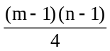 (B) 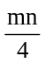
(C) 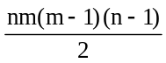 (D) 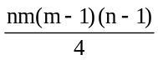

Q.45 The number of squares on a chess board is-
(A) 64 (B) 160
(C) 224 (D) 204

Q.46 The total number of rectangles on a chess board is-
(A) 1296 (B) 72
(C) 1200 (D) None of these

Q.47 The three sides AB, BC and CA of any ABC are having 3, 4, and 5 internal points respectively. Then the number of triangles formed by taking these points as the vertices are-
(A) 185 (B) 205
(C) 230 (D) 215

Q.48 If 4 parallel lines intersect another set of 3 parallel lines, then number of parallelograms formed with these lines is-
(A) 6 (B) 9
(C) 12 (D) 18

Q.49 The number of triangles whose vertices are at the vertices of an octagon but none of whose sides happen to come from the sides of the octagon is -
(A) 24 (B) 52 (C) 48 (D) 16

Q.50 There are m points on one straight line AB and n points on another straight line AC, none of them being A. How many triangles can be formed with these points as vertices?
(A) 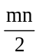(m + n)
(B) (m + n –2)
(C) (m + n –1)
(D) None of these

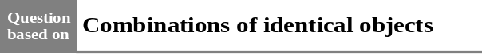

Q.51 The number of ways in which at least one fruit can be selected from 5 oranges, 4 apples, and
3 bananas is-
(A) 59 (B) 119
(C) 60 (D) 120

Q.52 The total number of donations which can be given from 5 one rupee coins and 4 fifty paise coins, is (at least one coin must be donated)-
(A) 19 (B) 29
(C) 30 (D) 20

Q.53 The number of ways in which at least one coin can be selected from 3 coins of one rupee, 4 coins of fifty paise, 5 coins of twenty paise and 6 coins of ten paise is -
(A) 639 (B) 840
(C) 839 (D) None of these

Q.54 In a library there are p copies of each n different books. The number of ways of selecting of one or more books from these is-
(A) (p+1)n –1 (B) (p+1)n
(C) (p–1)n – 1 (D) (p–1)n

Q.55 The number of divisors of 9600 is-
(A) 46 (B) 48
(C) 58 (D) 60

Q.56 The number of different proper factors of 3780 is-
(A) 45 (B) 46 (C) 47 (D) 48

Q.57 The total number of factors of 1998
(including 1 and 1998) is-
(A) 18 (B) 16 (C) 12 (D) 10

Q.58 Number of divisors of the form 4n + 2 (n ≥ 0) of the integer 240 is -
(A) 4 (B) 8 (C) 10 (D) 3

Q.59 If a, b, c, d, e are prime integers, then the number of divisors of ab2c2de excluding 1 as a factor, is -
(A) 94 (B) 72 (C) 36 (D) 71
Q.60 A basket contains 4 oranges, 5 apples and
6 mangoes. In how many ways can a person make a selection of fruits, if atleast one fruit have to be selected ?
(A) 210 (B) 209
(C) 120 (D) None of these

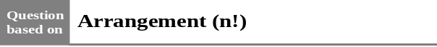
Q.61 The number of ways in which 8 answer books be arranged so that the best and the worst do not occur together is-
(A) 8! (B) 7!
(C) 7(7) ! (D) 6 (7)!

Q.62 There are 5 books on Mathematics, 4 on Physics. In how many ways these be placed on shelf if the books on the same subject are to be together?
(A) 4592 (B) 5760
(C) 4800 (D) 2672

Q.63 There are 10 students in a class in which three A, B, C are girls. The number of ways to arrange them in a row when any two girls out of three never comes together-
(A) 7! × 8P3 (B) 7! × 3P3
(C) 10! × 3P3 (D) None of these

Q.64 A shelf contains 20 books, of which 4 are single volume and the others are 8,5 and 3 volumes respectively. In how many ways can these books be arranged on the shelf so that the order of the volumes of same work is maintained ?
(A) 2.7! (B) 7!
(C) 8. 7! (D) None of these

Q.65 There are 5 different books on mathematics,
2 different books on chemistry and 4 different books on physics. The number of ways of arranging these books on a shelf so that books of the same subject are stacked together, is-
(A) 34560 (B) 11!
(C) 17285 (D) none of these

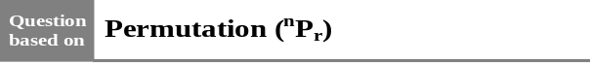
Q.66 If 15Pr = 2730, then the value of r is-
(A) 2 (B) 3 (C) 4 (D) 5

Q.67 If nP3 = 120, then the value of n is-
(A) 6 (B) 8 (C) 10 (D) 12

Q.68 nPn is equal to-
(A) nP1 (B) nPn–1
(C) nP0 (D) None of these

Q.69 n–1Pr + r ..n–1Pr–1 equals-
(A) nPr (B) n+1Pr+1
(C) n–1Pr+1 (D) None of these

Q.70 nPr is equal to -
(A) n.nPr–1 (B) n. n–1Pr–1
(C) (n-1) nP r–1 (D) None of these

Q.71 If nPn= 720, then n equals-
(A) 2 (B) 4 (C) 6 (D) 8

Q.72 If (m+n) P2 = 56 and m–nP2 = 12 then (m, n) equals-
(A) (5, 1) (B) (6, 2) (C) (7, 3) (D) (9, 6)

Q.73 For what value of r, nPr = 720 and nCr = 120 ?
(A) 6 (B) 5 (C) 4 (D) 3

Q.74 A tea party is arranged of 16 persons along two sides of a long table with 8 chairs on each side. 4 men wish to sit on one particular side and 2 on the other side. In how many ways can they be seated ?
(A) 8P4 × 8P2 (B) 8P4 × 8P2 × 10!
(C) 8P4 × 10! (D) None of these

Q.75 Eight chairs are numbered from 1 to 8. Two women and three men wish to occupy one chair each. First women choose the chairs from amongst the chairs marked 1 to 4; and then the men select the chairs from the remaining. The number of possible arrangements is-
(A) 6C3 × 4C2 (B) 4P3 × 4P3
(C) 4C2 × 4P3 (D) None of these
Q.76 Eleven animals of a circus have to be placed in eleven cages, one in each cage. If four of the cages are too small for six of the animals, the number of ways of caging the animals is-
(A) 7P6. 5! (B) 6P4. 7!
(C) 11C4. 7! (D) None of these

Q.77 The number of ways in which three persons can dress themselves when they have 4 shirts. 5 pants and 6 hats between them, is-
(A) 4C3 × 5C3 ×6C3 (B) 4P3× 5 P3 × 6 P3
(C) 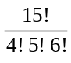 (D) 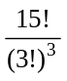

Q.78 How many signals can be given by means of 10 different flags when at a time 4 flags are used, one above the other?
(A) 10P4 (B) 10C4
(C) 4 (D) 40

Q.79 A boat crew consist of 8 men, 3 of whom can only row on one particular side and 2 only on the other. The number of ways in which the crew can be arranged is-
(A) 1728 (B) 576
(C) 72 (D) None of these

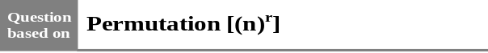
Q.80 In how many ways can six different rings be wear in four fingers?
(A) 6P4 (B) 64
(C) 46 (D) 6C4

Q.81 The number of ways in which n prizes can be distributed among n students when each student is eligible to get any number of prizes is-
(A) nn (B) n!
(C) nn - n (D) None of these

Q.82 The number of ways of distributing n prizes among n boys when any of the student does not get all the prizes is-
(A) nn (B) n!
(C) nn– n (D) None of these

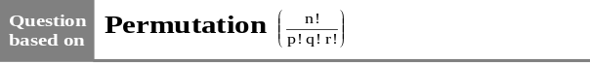
Q.83 The number of permutations of the letters
x, x, y, y, y, y, z, z, z will be -
(A) 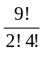 (B) 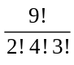
(C) 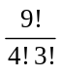 (D) 9!

Q.84 In how many ways can 21 identical white and 19 identical black balls be put in a row so that no two black balls are together?
(A) 1470 (B) 1540
(C) 735 (D) None of these

Q.85 If out of 8 flags, 5 flags are white (identical) and 3 flags are of red colour (identical), then how many signals can be given by using all of them at a time?
(A) 15 (B) 28
(C) 56 (D) 126

Q.86 A coin is tossed 10 times. In how many different ways can we obtain 5 head and 5 tails-
(A) 25 (B) 252
(C) 52 (D) 22

Q.87 Six identical coins are arranged in a row. The number of ways in which the number of tails is equal to the number of heads is-
(A) 20 (B) 9
(C) 120 (D) 40

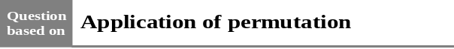
Q.88 How many words can be formed from the letters of the word ‘BHOPAL’ -
(A) 124 (B) 240
(C) 360 (D) 720

Q.89 In how many ways can the letters of the word ‘SIMPLETON’ be rearranged?
(A) 9! (B) 9! – 1
(C) 9! – 2 (D) 8! – 1

Q.90 The number of different words formed with all the letters of the word ‘MISISSIPI’ is-
(A) 2500 (B) 2460
(C) 2520 (D) None of these

Q.91 The total number of words formed with the letters of the word “SERIES’ is-
(A) 720 (B) 180
(C) 360 (D) None of these

Q.92 The number of permutations formed without changing the position of vowel and consonants of the letters of word ‘ALGEBRA’-
(A)144 (B) 70
(C) 360 (D) 72

Q.93 The number of words which can be formed from the letters of the word ‘JODHPUR’ so that P,U,R always remain together is-
(A) 4320 (B) 120
(C) 720 (D) None of these

Q.94 The number of words from the letters of ‘BHARAT’ is where B and H will never come together-
(A) 240 (B) 120 (C) 140 (D) 40

Q.95 How many words can be formed from the letters of the word ‘GANESH PURI’ when P and I occupy the first and last place respectively-
(A) 2! × 8! (B) 8!
(C) 10! (D) None of these

Q.96 The number of words which can be formed from the letters of the word ‘SCHOLAR’ which begin with A and end with S is-
(A) 120 (B) 720
(C) 1440 (D) 5040

Q.97 The number of words formed with the letters of the word ‘JODHPUR’ in which P, U, R never come together, is-
(A) 720 (B) 5040
(C) 4320 (D) None of these

Q.98 The number of different words from the letters of the word “ALLAHABAD” in which vowels occupy even positions, are-
(A) 1440 (B) 7560
(C) 240 (D) 60

Q.99 How many words can be formed by using the letters of the word ‘INSURANCE’, when vowels always remain together?
(A) 8640 (B) 17280
(C) 720 (D) None of these

Q.100 The number of words which can be formed by using the letters of the word ‘INDEPENDENCE’ so that both D occur together is-
(A) 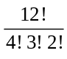 (B) 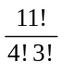
(C) 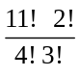 (D) None of these

Q.101 How many different permutations can be formed from the letters of the word ‘MATHEMATICS” which starts from C-
(A) 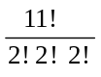 (B) 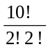
(C) 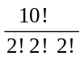 (D) None of these

Q.102 The number of words from the letters of the word ‘INSTITUTION’ when first two letters are N-
(A) 5040 (B) 32240
(C) 20160 (D) 10080

Q.103 How many words can be formed from the letters of word ‘ASSASSINATION” when four S remains together-
(A) 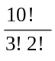
(B) 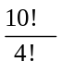
(C) 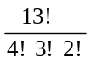
(D) 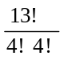

Q.104 How many different words can be formed from the letters of ‘CONSTANTINOPLE’ in which all three N come together?
(A) 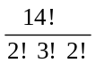 (B) 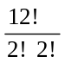
(C) 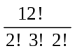 (D) None of these

Q.105 How many words with the letters of the word ‘CARAVELLE’ can be formed which starts with R-
(A) 8! (B) 5040
(C) 1080 (D) None of these

Q.106 How many numbers of 4 digits can be formed from the digits 1, 2, 3, 4, 5, 6 (repetition is not allowed)
(A) 240 (B) 150
(C) 720 (D) 360

Q.107 How many numbers lying between 100 and 1000 can be formed with the digits 1, 2, 3, 4, 5 if the repetition of digits is not allowed -
(A) 62 (B) 60 (C) 64 (D) 65

Q.108 How many numbers between 30000 and 40000 can be formed with the digits 2, 3, 5, 6, 9 if each digit can be repeated any number of times?
(A)45 (B) 55
(C) 44 (D) 54

Q.109 How many numbers consisting of 5 digits can be formed in which the digits 3,4 and 7 are used only once and the digit 5 is used twice-
(A) 30 (B) 60
(C) 45 (D) 90

Q.110 The number of 5 digit even numbers formed with the digits 2, 3, 5, 7, 9 is (Rept. not allowed)
(A) 12 (B) 24
(C) 120 (D) None of these

Q.111 Using digits 3, 4, 5, 6, 7, 8 how many numbers between 3000 and 4000 can be formed which are divisible by 5 and same digit is not repeated ?
(A) 60 (B) 12
(C) 120 (D) 24

Q.112 How many numbers can be formed with the digits 3, 4, 5, 6, 7 which are greater than 1000 (Repetition not allowed) ?
(A) 240 (B) 120
(C) 24 (D) 5

Q.113 How many 4 digit numbers can be formed with digits 1, 2, 3, 4, 5 when digits may be repeated ?
(A) 125 (B) 625
(C) 1024 (D) None of these

Q.114 How many five digit even numbers can be formed by using the digits 0, 2, 3, 4, 5
(Repetition not allowed)?
(A) 72 (B) 60
(C) 54 (D) 36

Q.115 The number of 4-digits numbers formed with
0, 2, 3, 4, 5, and divisible by 5 is
(Repetition not allowed)
(A) 42 (B) 36
(C) 48 (D) 24

Q.116 The number of 4 digits odd numbers formed with the digits 0, 1, 2, 3, 4 and 5 is
(Repetition not allowed)
(A) 54 (B) 144
(C) 180 (D) 360

Q.117 How many numbers can be formed with the digits 2,3,5,7,0 which are greater than 70,000 (Repetition not allowed) ?
(A) 24 (B) 12
(C) 120 (D) 6

Q.118 The number of numbers can be formed by taking any 2 digits from digits 6,7,8,9 and 3 digits from 1, 2, 3, 4, 5 is -
(A) 5C3 × 4C2 × 3! × 2!
(B) 5P3 × 4 P2 × 5!
(C) 5C3 × 4C2 × 5!
(D) 5C3 × 4C2 × 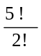

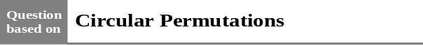

Q.119 The number of ways in which 20 persons can sit on 8 chairs round a circular table is-
(A) 20 P8 (B) 19P8
(C) 1/8 (20P8) (D) None of these

Q.120 Eleven members of a committee sit round a circular table. In how many ways can they sit so that the secretary and joint secretary are always neighbours of the president?
(A) 8! × 3! (B) 10!
(C) 8! × 2! (D) 7! × 2!

Q.121 In how many ways 7 different beads be strung into a ring so that two particular beads are always together?
(A) 240 (B) 720 (C) 120 (D) 360

Q.122 The number of necklaces which can be formed by selecting 4 beads out of 6 beads of different coloured glasses and 4 beads out of 5 beads of different metal, is-
(A) 6P4 × 5P4 × 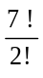 (B) 6C4 × 5C4 ×
(C) 6C4 × 5C4 × 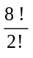 (D) 6C4 × 5C4 × 7!

Q.123 If two specific beads are kept together, then in how many ways can seven different beads be strung in one garland-
(A) 5! (B) 7!
(C) 5! × 2! (D)

Q.124 There are 20 persons among whom two are brothers. The number of ways in which we can arrange them round a circle so that there is exactly one person between the two brothers, is-
(A) 18! (B) 2(18!)
(C) 2 (19!) (D) None of these

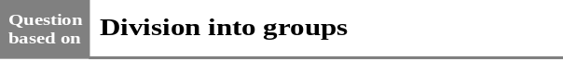

Q.125 The number of ways to make 5 heaps of 3–3 books each from 15 different books a-
(A) 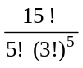 (B) 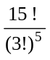
(C) 15C3 (D) 15P5

Q.126 150 students take admission. They are to be put in three sections A, B, C of equal size. The number of ways in which this can be done is-
(A) 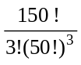 (B)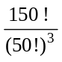
(C) × 150! (D) None of these

Q.127 In how many ways can a pack of 52 cards be divided equally among four players in order to-
(A) 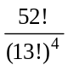 (B)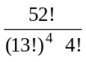
(C) 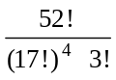 (D) None of these

Q.128 The number of ways in which six different prizes can be distributed among three children each receiving at least one prize is-
(A) 270 (B) 540
(C) 1080 (D) 2160

Q.129 The number of ways in which 20 volunteers can be divided into groups of 4, 7 and 9 persons is-
(A) 16C7× 13C2 (B) 20C7 × 11C4
(C) 20C4 × 16C7 (D) 20C9 × 13C9

Q.130 The number of ways in which mn students can be distributed equally among n sections is-
(A) (mn)n (B) 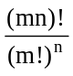
(C) 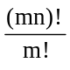 (D) 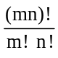

Q.131 In how many ways two garlands of 6 flowers each can be made from 12 different flowers-
(A) 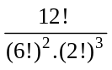.(5!)² (B) 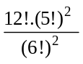
(C) 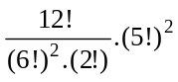 (D) 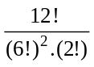

Q.132 In how many ways 8 different balls can be distributed among 3 children so that one child gets 4 balls and two children get 2 balls each?
(A) 210 (B) 240
(C) 420 (D) 1260

Q.133 In how many ways can 6 prizes be distributed equally among 3 persons?
(A) 6C2 × 4C2 (B) 6P2 × 4P2
(C) 3 (D) 36

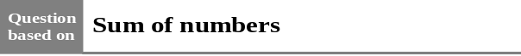

Q.134 The sum of numbers formed by the digits
1, 3, 5, 7, 9 is-
(A) 666600 (B) 6666600
(C) 666660 (D) None of these

Q.135 The sum of all numbers greater than 1000 formed by using the digits 1,3,5,7 no digit is repeated in any number is-
(A) 106656 (B) 101276
(C) 117312 (D) 811273

Q.136 The sum of the digits in the unit place of all the numbers formed with the help of 3, 4, 5, 6 taken all at a time is-
(A) 18 (B) 108
(C) 432 (D) None of these

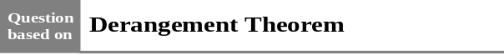

Q.137 The number of ways to put five letters in five envelopes when any one letter is kept in right envelope and four letters in wrong envelopes are-
(A) 40 (B) 45
(C) 30 (D) 70
Q.138 There are four balls of different colours and four boxes of colours same as those of the balls. The number of ways in which the balls, one in each box, could be placed such that a ball does not go to box of its own colour is-
(A) 8 (B) 7
(C) 9 (D) None of these

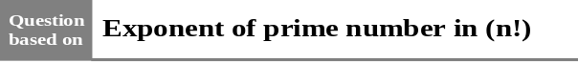

Q.139 The exponent of 7 in 100! is -
(A) 14 (B) 15
(C) 16 (D) none of these

Q.140 The number of zeros at the end of 70 ! is -
(A) 16 (B) 5
(C) 7 (D) 70

Q.141 The number 24 ! is divisible by -
(A) 624 (B) 246
(C) 1212 (D) 485

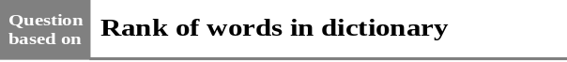

Q.142 The letters of the word RANDOM are written in all possible orders and these words are written out as in a dictionary then the rank of the word RANDOM is -
(A) 614 (B) 615
(C) 613 (D) 616

Q.143 If the letters of the word MOTHER are written in all possible orders and these words are written out as in dictionary, then the rank of the word MOTHER is -
(A) 240 (B) 261
(C) 308 (D) 309

Q.144 All letters of the word 'AGAIN' are permuted in all possible ways and the words so formed (with or without meaning) are written as in dictionary, then the 50th word is -
(A) NAAGI (B) NAAIG
(C) IAANG (D) INAGA.

level- 2

Q.1 A box contains two different white balls, three different black balls and four different red balls. In how many ways can three balls be drawn from the box if at least one black ball is to be included in the draw?
(A) 129 (B) 84
(C) 64 (D) None of these

Q.2 The number of word groups by taking at least 1 letters of each words ‘PATH’, ‘GROW’ and ‘SKIN’ are-
(A) 15³ –1 (B) 15³
(C) 16³ – 1 (D) 16³

Q.3 Four dice are rolled. The number of possible outcomes in which at least one die shows 2 is-
(A) 1296 (B) 625
(C) 671 (D) None of these

Q.4 The number of words which can be formed from the letters of the word MAXIMUM, if two
consonants cannot occur together, is-
(A) 4! (B) 3! × 4!
(C) 7! (D) None of these

Q.5 How many six letter words be made out of the letters of ‘ASSIST? In how many words the alphabet S alternates with other letters?
(A) 120, 6 (B) 720, 12
(C) 120, 12 (D) 720, 24

Q.6 In how many ways the alphabets of the word ‘MULTIPLE’ can be ordered other than itself, when the order of vowels is not changed?
(A) 3360 (B)3359
(C) 6720 (D) 20160

Q.7 The total number of words which can be formed using letters of the word ‘FAILURE’ so that consonants always occupy odd places, is-
(A) 144 (B) 576
(C) 5040 (D) None of these

Q.8 The number of words formed from letters of the word ‘EAMCET’ so that no two vowels come together, is-
(A) 360 (B) 144 (C) 72 (D) 54

Q.9 How many 5 digit odd numbers can be formed with the help of digits 0, 2, 3, 4 and 6
(Rept. not allowed) ?
(A) 18 (B) 24 (C) 96 (D) 120

Q.10 How many four digit numbers from the digits
0, 1, 2, 3 will contain 3 at unit place
(Repetition not allowed)
(A) 6 (B) 18
(C) 4 (D) None of these

Q.11 The number of numbers of 4 digits which are not divisible by 5 are (when repetition is allowed)-
(A) 7200 (B) 3600
(C) 14400 (D) 1800

Q.12 How many 5 digit numbers be formed by the digits 1, 2, 3, 4, 5 which are divisible by 4
(Repetition not allowed) ?
(A) 24 (B) 120
(C) 72 (D) None of these

Q.13 The total number of 5- digit numbers formed with the digits 0, 1, 2, 3, 4 and 5 which are divisible by 3, is (Repetition not allowed) -
(A) 216 (B) 240
(C) 600 (D) 3125

Q.14 How many 6 digit different number can formed with help of the digits of numbers 121 and 202?
(A) 25 (B) 50
(C) 100 (D) None of these

Q.15 The number of 4 - digit numbers formed with the digits 1, 2, 3, 4, 5, 6, 7 which are divisible by 25 is (Repetition not allowed) -
(A) 20 (B) 30
(C) 40 (D) None of these
Q.16 The number of six digit numbers that can be formed from the digits 1, 2, 3, 4, 5, 6 and 7 so that terminal digits are even is-
(A) 72 (B) 720
(C) 144 (D) 288

Q.17 Using all digits 2, 3, 4, 5, 6, how many even numbers can be formed?
(A) 24 (B) 48
(C) 72 (D) 120

Q.18 How many non zero numbers can be formed with the help of digits 0, 1, 2, 3, 4, when no digit is repeated in any number?
(A) 260 (B) 336
(C) 410 (D) None of these

Q.19 How many four digits numbers can be formed with digits 1, 2, 3, 4, 5, 6 when it includes 1 and 2 necessarily (Repetition not allowed) ?
(A) 6 (B) 288
(C) 144 (D) 48

Q.20 The total number of seven digit numbers the sum of whose digits is even is-
(A) 9000000 (B) 4500000
(C) 8100000 (D) None of these

Q.21 The number of times the digit 3 will be written when listing 1 to 1000 is ……
(A) 300 (B) 271
(C) 302 (D) 269

Q.22 The number of ways in which any four letters can be selected from the word ‘CORGOO’ is-
(A) 15 (B) 11
(C) 7 (D) None of these

Q.23 The total number of ways of selecting five letters
from the letters of the word
‘INDEPENDENT’ is-
(A) 72 (B) 3320
(C) 120 (D) None of these

Q.24 In how many ways can a selection of 4 letters be made out of the letters of the word
‘MATHEMATICS’?
(A) 136 (B) 330
(C) 70 (D) None of these

Q.25 The number of words which can be formed by taking two same and two different letters from the letters of the word ‘COMBINATION’ is-
(A) 756 (B) 1512
(C) 252 (D) None of these

Q.26 Taking three same and one different letters from the letters of the word ‘PROPORTION’, the number of words which can be formed is-
(A) 18 (B) 360
(C) 20 (D) None of these

Q.27 How many words can be formed by taking three letters from the letters of the word ‘SERIES’?
(A) 24 (B) 18
(C) 42 (D) None of these

Q.28 The number of words which can be formed using 4 letters of the word ‘EXAMINATION’ is-
(A) 1896 (B) 2136
(C) 2454 (D) None of these

level- 3

Q.1 The number of rectangles in the adjoining figure is -
(A) 5 × 5
(B) 5P2 × 5P2
(C) 5C2 × 5C2
(D) None of these

Q.2 In a plane there are 37 straight lines, of which 13 pass through the point A and 11 pass through the point B. Besides, no three lines pass through one point, no line passes through both points A and B, and no two are parallel. Then the number of intersection points the lines have is equal to-
(A) 535 (B) 601
(C) 728 (D) None of these.

Q.3 The number of numbers between 1 and 1010 which contain the digit 1 is-
(A) 1010 – 910 – 1 (B) 910
(C) 1010 – 810 (D) None of these.

Q.4 A set contains (2n + 1) elements. If the number of subsets of this set which contain at most n elements is 4096, then the value of n is-
(A) 6 (B) 15
(C) 21 (D) None of these.

Q.5 How many different nine digit numbers can be formed from the number 223355888 by rearranging its digits so that the odd digits occupy even positions ?
(A) 16 (B) 36
(C) 60 (D) 180

Q.6 All possible two factors products are formed from numbers 1, 2, 3, 4, ........, 200. The number of factors out of the total obtained which are multiples of 5 is-
(A) 5040 (B) 7180
(C) 8150 (D) None of these

Q.7 If n objects are arranged in a row, then the number of ways of selecting three of these objects so that no two of them are next to each other is-
(A) n – 2C3 (B) n – 3C2
(C) n – 3C3 (D) None of these

Q.8 Between two junction stations A and B there are 12 intermediate stations. The number of ways in which a train can be made to stop at 4 of these stations so that no two of these halting stations are consecutive is-
(A) 8C4 (B) 9C4
(C) 12C4 – 4 (D) None of these

Q.9 The number of integral solutions of x + y + z = 0 with x ≥ – 5, y ≥ – 5, z ≥ – 5 is-
(A) 135 (B) 136
(C) 455 (D) 105

Q.10 The number of non-negative integral solutions of x + y + z ≤ n, where n ∈ N is -
(A) n + 3C3 (B) n + 4C4
(C) n + 5C5 (D) None of these

Q.11 The number of ways is which an examiner can assign 30 marks to 8 questions, giving not less than 2 marks to any question is -
(A) 21C7 (B) 21C8
(C) 21C9 (D) 21C10

Q.12 Number of ways of placing 5 identical balls in
3 identical boxes (no box remains empty), is-
(A) 6 (B) 2
(C) 3 (D) None of these.

Q.13 Number of ways of placing 5 identical balls in
3 different boxes (no box remain empty), is–
(A) 6 (B) 12
(C) 150 (D) None of these.

Q.14 Number of ways of placing 5 different balls in
3 identical boxes (no box remains empty), is-
(A) 50 (B) 10
(C) 25 (D) none of these

Q.15 Number of ways of placing 5 different balls in
3 different boxes (no box remains empty), is-
(A) 10 (B) 15
(C) 25 (D) 150

Questions based on statements (Q. 16 - 18)
Each of the questions given below consists of
Statement – I and Statement – II. Use the following Key to choose the appropriate answer.
(A) If both Statement - I and Statement - II are true, and Statement - II is the correct explanation of Statement- I.
(B) If both Statement-I and Statement - II are true but Statement - II is not the correct explanation of Statement-I.
(C) If Statement-I is true but Statement - II is false.
(D) If Statement-I is false but Statement - II is true.

Q.16 Statement I : 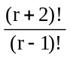 is divisible by 6.
Statement II : Product of three consecutive integers is divisible by 3!.

Q.17 Statement I: The exponent of 7 in 100C50 is 4.
Statement II : The number of ways in which we can post 5 letters in 12 boxes is 125.

Q.18 Statement I : The number of ways of dividing n identical objects among r groups is n+r–1Cn.
Statement II : The number of ways of dividing n identical objects among r groups is equal to number of arranging n identical objects of one kind and (r – 1) identical objects of other kind in a row. Therefore, it is equal to
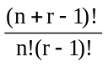 = n+r–1Cn.

ANSWER KEY
level- 1
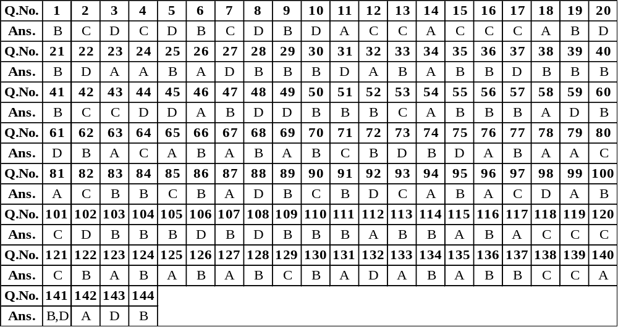

level- 2
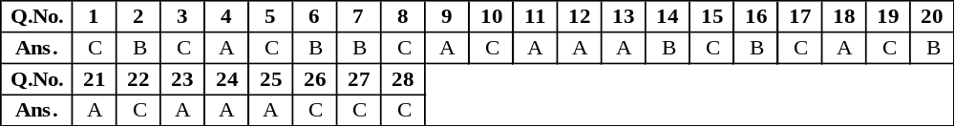
level- 3

